Migration to Britain c. 400 to 1500
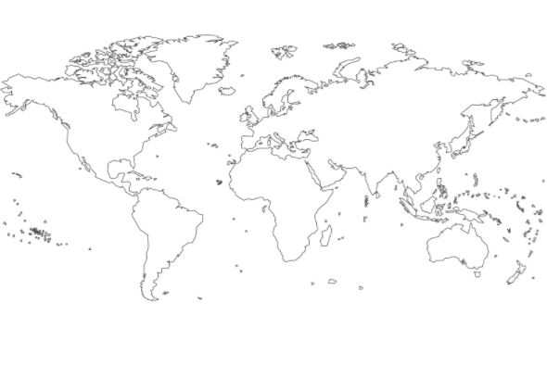

Migration to Britain 1500-1750
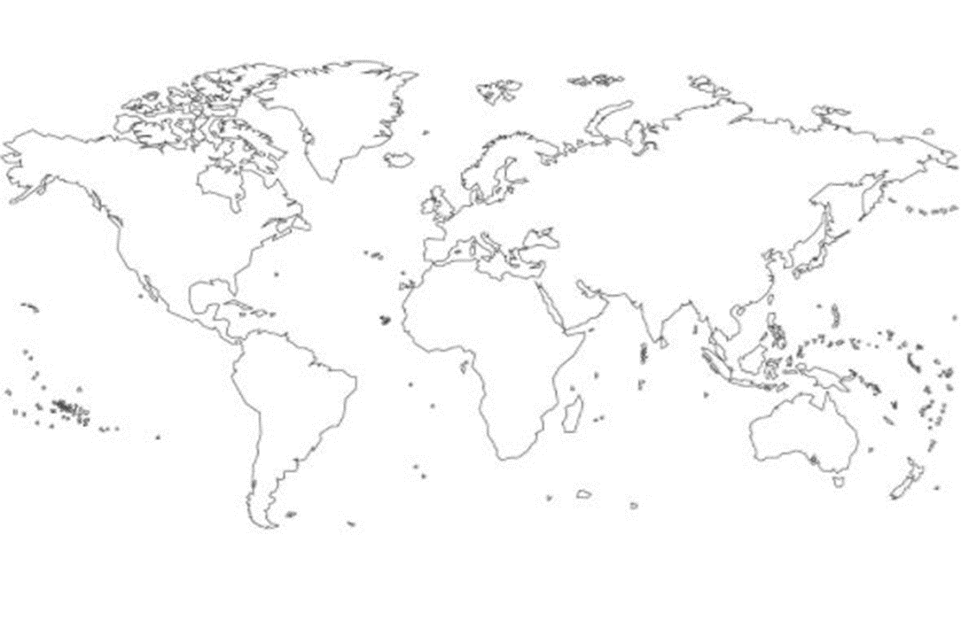
Migration to Britain 1750-1900

Migration to Britain 1900-2010

